ACTIVITY 5
NAME: Rose Mystica. J COURSE: MOBILE COMPUTING
REG NO : 192421410 COURSE CODE: ITA0302

5. Design a wireframe for a mobile application that incorporates localization features using
Figma.
Aim: -
To design a wireframe using Figma for a mobile application that incorporates localization
features
Procedure: -
1. open Figma
2. Create a new file
3. Select the Frames
4. Design Visual Elements
5. Make it Interactive
6. Add icons on the Frame
7. Incorporate Multimedia
8. Storyboard Animation
9. Review and edit the Prototype
10. Save and Share
Design:-
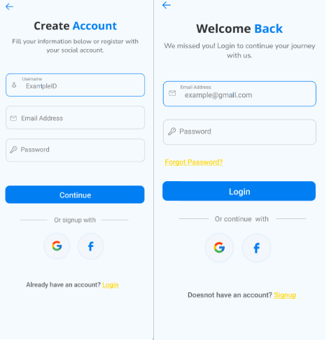
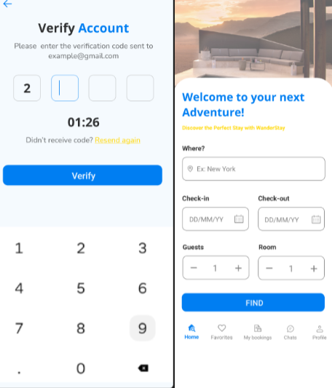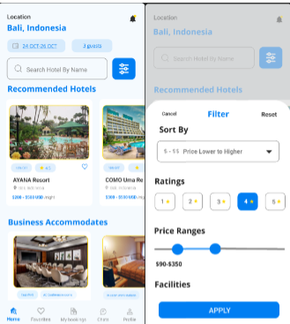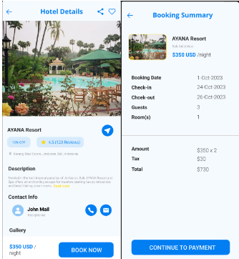
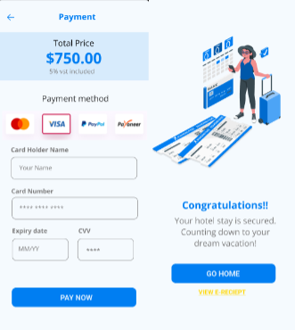

Prototype:
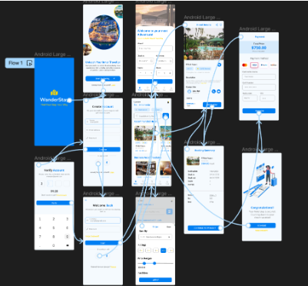
Result: -
Hence the wireframe for a mobile application that incorporates localization features using Figma
is created and executed successfully

